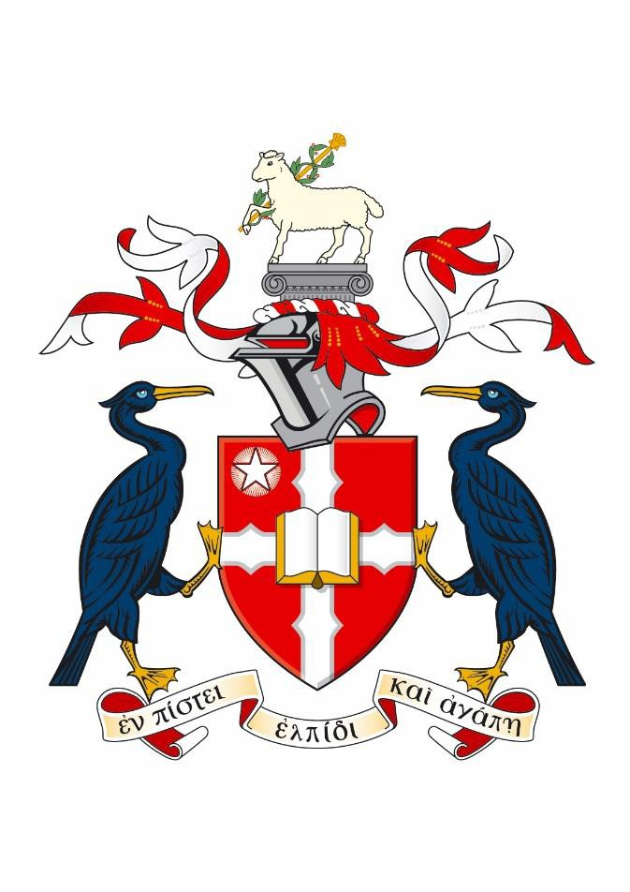
Liverpool Hope University

Partnership Register

PARTNERSHIP/ COLLABORATIONS

Partner | Location | Agreement Type | Provision | Department / School | Agreement Expiry date
Holy Cross College, Bury (Network of Hope) | UK | Network of Hope  Agreement | - Combined BA (Hons) Degrees (Holy Cross courses) | Business School  School of Education  School of Humanities  School of Social Science | 31.08.2023
Maryvale Institute, Birmingham | UK | Sub-contractual Agreement | - MPhil and PhD | School of Humanities | 31.08.2026
Newman University, Birmingham | UK | Sub-contractual Agreement | - MEd, MPhil, PhD and EdD (various subjects) | Across all Schools / Departments | 31.12.2022
Spurgeon’s College, London | UK | Validation Agreement | - MA Digital Theology | School of Humanities | 31.08.2023
St Mary’s University, Twickenham | UK | Sub-contractual Agreement | - MPhil, PhD and EdD (various subjects) | All Schools / Departments | 30.09.2026
Université Catholique de Lille | France | Articulation Agreement | - International Masters in Business Administration | Business School | 31.08.2026

SCHOOL DIRECT/SCITT

School Direct /SCITT Partner | Agreement Type | Provision | Agreement Expiry
Aspirational Teaching School Alliance, St. Helens (Hope Academy) | School Direct Contract | PGCE Secondary – Recommended for QTS | 31.08.2023
Associated Merseyside Partnership SCITT - DEYES | SCITT Contract | PGCE | 31.08.2023
Birkenhead North Schools Partnership (Our Lady & St Edwards Catholic Primary School) | School Direct Contract | PGCE Primary – Recommended for QTS | 31.08.2024
Cranmer Education Trust - BLUECOAT | SCITT Contract | PGCE | 31.08.2023
Grange Valley Primary School and Nursery | School Direct Contract | PGCE Primary – Recommended for QTS | 31.08.2024
Greenbank Primary School | School Direct Contract | PGCE Primary – Recommended for QTS | 31.08.2024
Liverpool College | School Direct Contract | PGCE Primary – Recommended for QTS  PGCE Secondary – Recommended for QTS | 31.08.2024
Millstead Primary School | School Direct Contract | PGCE Primary – Recommended for QTS | 31.08.2024
Oldham Academy North | School Direct Contract | PGCE Secondary – Recommended for QTS | 31.08.2024
St James Church of England High School | School Direct Contract | PGCE Secondary – Recommended for QTS | 31.08.2024
St John Bosco Arts College | School Direct Contract | PGCE Secondary – Recommended for QTS | 31.08.2024
Saint Patrick’s Greater Manchester Alliance (St Patrick’s RC High School) | School Direct Contract | PGCE Primary – Recommended for QTS  PGCE Secondary – Recommended for QTS | 31.08.2023
Warrington Teaching School Alliance (Evelyn Street Primary School) | School Direct Contract | PGCE Primary – Recommended for QTS | 31.08.2024
Wigan and West Lancashire Catholic School Direct (St Edmund Arrowsmith Catholic High School) | School Direct Contract | PGCE Secondary – Recommended for QTS | 31.08.2023
Wigan Catholic Primary School Direct (St Patrick’s Catholic Primary School) | School Direct Contract | PGCE Primary – Recommended for QTS | 31.08.2024

STUDY ABROAD/MAYMESTER PARTNERS

Study Abroad/Exchange Partner | Location | Agreement Type | Expiry
Agnes Scott College | USA | Study Abroad Agreement | 2027
Anderson University* | USA | Study Abroad & Maymester Agreement | 2027
Ateneo de Manila University | Philippines | Study Abroad Agreement | 2027
Baylor University* | USA | Study Abroad & Maymester Agreement | 2027
Bluefield University* | USA | Study Abroad & Maymester Agreement | 2027
Blue Mountain College* | USA | Study Abroad & Maymester Agreement | 2027
Cairn University* | USA | Study Abroad & Maymester Agreement | 2027
California Lutheran University* | USA | Study Abroad Agreement | 2027
Calvin University | USA | Study Abroad Agreement | 2027
Campbell University* | USA | Study Abroad & Maymester Agreement | 2027
Campbellsville University* | USA | Study Abroad & Maymester Agreement | 2027
Cardinal Stritch University | USA | Study Abroad & Maymester Agreement | 2027
Carson-Newman University* | USA | Study Abroad & Maymester Agreement | 2027
Concordia College | USA | Study Abroad & Maymester Agreement | 2027
Dallas Baptist University* | USA | Study Abroad & Maymester Agreement | 2027
Elmhurst College | USA | Study Abroad & Maymester Agreement | 2027
Gardner-Webb University* | USA | Study Abroad & Maymester Agreement | 2027
Hannibal-LaGrange University* | USA | Study Abroad & Maymester Agreement | 2027
Hardin-Simmons University* | USA | Study Abroad & Maymester Agreement | 2027
Howard Payne University* | USA | Study Abroad & Maymester Agreement | 2027
Louisiana Christian University* | USA | Study Abroad & Maymester Agreement | 2027
Mary-Hardin Baylor University* | USA | Study Abroad & Maymester Agreement | 2027
Mississippi College* | USA | Study Abroad & Maymester Agreement | 2027
Missouri Baptist University* | USA | Study Abroad & Maymester Agreement | 2027
Musashino University | Japan | Study Abroad & Maymester Agreement | 2027
North Greenville University* | USA | Study Abroad & Maymester Agreement | 2027
Notre Dame Seishin University | Japan | Study Abroad Agreement | 2027
Oklahoma Baptist University* | USA | Study Abroad & Maymester Agreement | 2027
Ouachita Baptist University* | USA | Study Abroad & Maymester Agreement | 2027
Samford University* | USA | Study Abroad & Maymester Agreement | 2027
Shorter University* | USA | Study Abroad & Maymester Agreement | 2027
Southwest Baptist University* | USA | Study Abroad & Maymester Agreement | 2027
Study Abroad/Exchange Partner | Location | Agreement Type | Renewal
St Ambrose University | USA | Study Abroad & Maymester Agreement | 2027
St. Gallen, University of Teacher Education | Switzerland | Study Abroad Agreement | 2027
Susquehanna University | USA | Study Abroad & Maymester Agreement | 2027
Union University* | USA | Study Abroad & Maymester Agreement | 2027
Universidad Iberoamericana | Mexico | Study Abroad & Maymester Agreement | 2027
Universidad Intercontinental | Mexico | Study Abroad & Maymester Agreement | 2027
Universidad La Salle AC | Mexico | Study Abroad Agreement | 2027
Universidad Panamericana | Mexico | Study Abroad & Maymester Agreement | 2027
University de Monterrey (UDEM) | Mexico | Study Abroad & Maymester Agreement | 2027
University of Memphis | USA | Study Abroad Agreement | 2027
University of Mobile* | USA | Study Abroad & Maymester Agreement | 2027
University of the Cumberlands* | USA | Study Abroad & Maymester Agreement | 2027
UW- Parkside | USA | Study Abroad & Maymester Agreement | 2027
UW - Stevens Point | USA | Study Abroad & Maymester Agreement | 2027
Wayland Baptist University* | USA | Study Abroad & Maymester Agreement | 2027
William Carey University* | USA | Study Abroad & Maymester Agreement | 2027
Women’s Christian College | India | Study Abroad Agreement | 2027

* Study Abroad/Maymester partnerships via the Consortium for Global Education (GCE)

EXCHANGE PARTNERS
Study Abroad/Exchange Partner | Location | Agreement Type | Renewal
Alverno College | USA | Exchange Agreement | AY 2022/23
Hogeschool Van Arnhem en Nijmegen | Netherlands | Exchange Agreement | AY 2022/23
Hong Kong Baptist University | Hong Kong | Exchange Agreement | AY 2022/23
Hope College Michigan | USA | Exchange Agreement | AY 2022/23
Lock Haven University | USA | Exchange Agreement | AY 2022/23
North Park University | USA | Exchange Agreement | AY 2022/23
Trent University | Canada | Exchange Agreement | AY 2022/23
Université Catholique de Lille | France | Exchange Agreement | AY 2022/23
Université Catholique de L'Ouest | France | Exchange Agreement | AY 2022/23
Université Jean Moulin Lyon 3 | France | Exchange Agreement | AY 2022/23
University of South-Eastern Norway | Norway | Exchange Agreement | AY 2022/23
University of Limerick | Ireland | Exchange Agreement | AY 2022/23
University of Malta | Malta | Exchange Agreement | AY 2022/23
University of Mississippi | USA | Exchange Agreement | AY 2022/23
University of South-Eastern Norway | Norway | Exchange Agreement | AY 2022/23
University of West Alabama | USA | Exchange Agreement | AY 2022/23
University San Pablo CEU | Spain | Exchange Agreement | AY 2022/23
VIA University College (Viborg) | Denmark | Exchange Agreement | AY 2022/23
Vives University College | Belgium | Exchange Agreement | AY 2022/23

Partnership with Maryvale not renewed – run off period to 2026 to see out the current cohorts
Spurgeon’s College awarded TDAP and are now recruiting students directly; the agreement is now in a period of run off to see out the current cohorts
St Mary’s awarded RDAP and are now recruiting students directly; the agreement is now in a period of run off to see out the current cohorts
All Exchange agreements are being renewed during AY 2022/23

